**NAMES :Iradukunda Deborah**

**ID:29121**

**DBMS ASSIGNMENT**

**String Function Exercises (15)**

1. **Concatenate first and last name as full_name.**

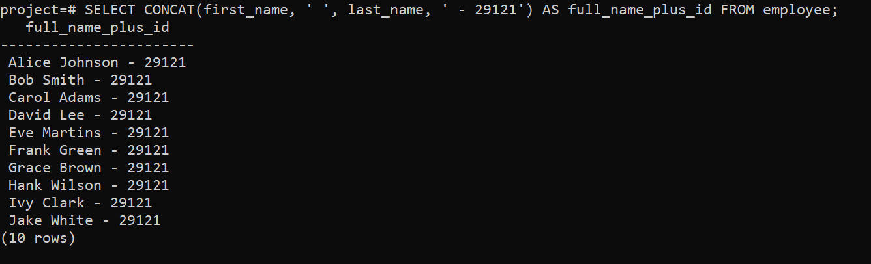

1. **Convert all employee names to lowercase.**

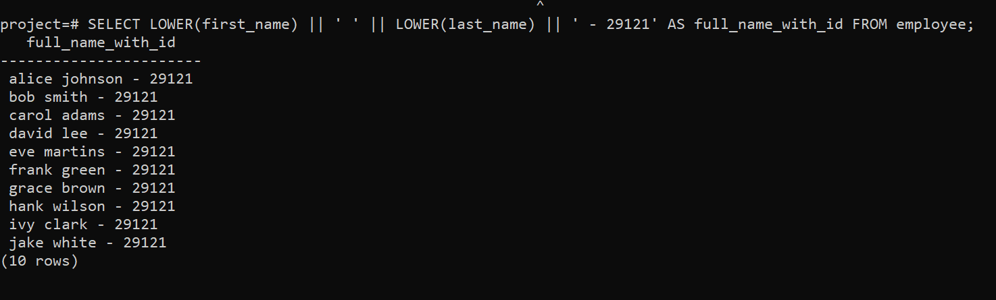

1. **Extract first 3 letters of the employee's first name.**

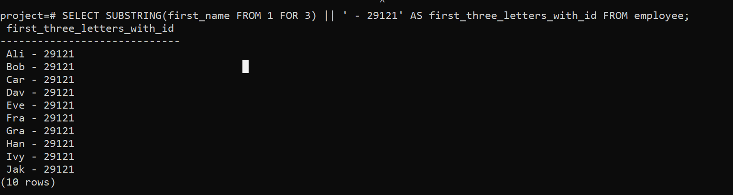

1. **Replace '@company.com' in email with '@org.com'.**

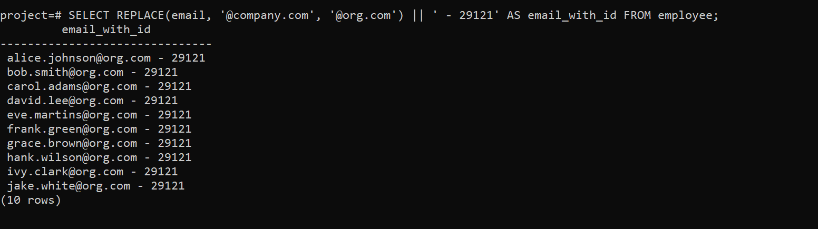

1. **Trim spaces from a padded string.**

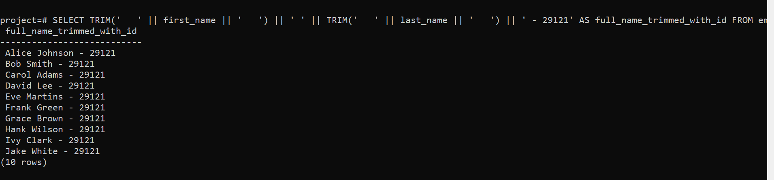

1. **Count characters in an employee’s full name.**

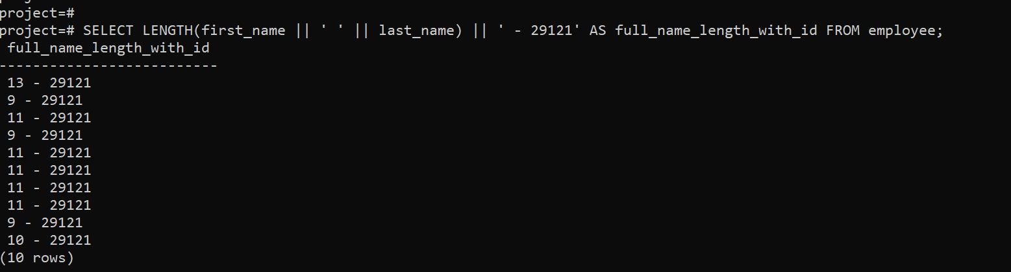

1. **Find position of '@' in email using INSTR()/CHARINDEX().**

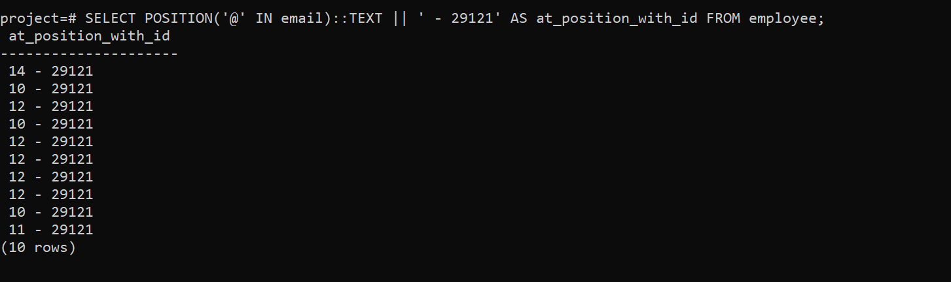

1. **Add ‘Mr.’ or ‘Ms.’ before names based on gender (assume gender exists).**

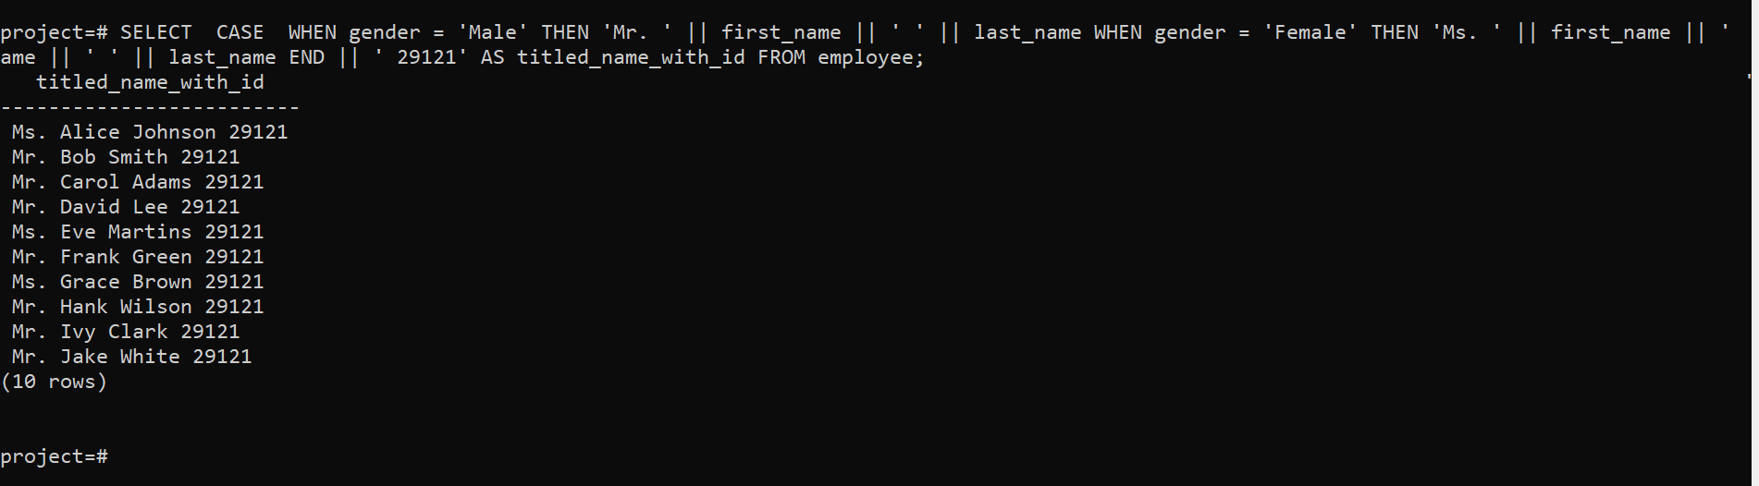

1. **Format project names to uppercase.**

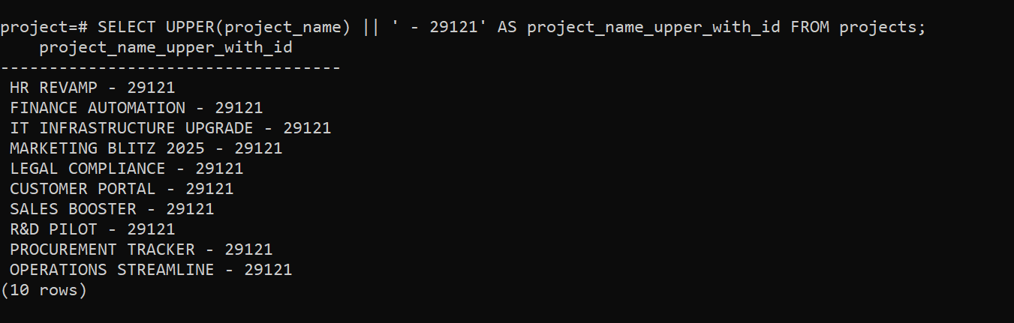

1. **Remove any dashes from project names.**

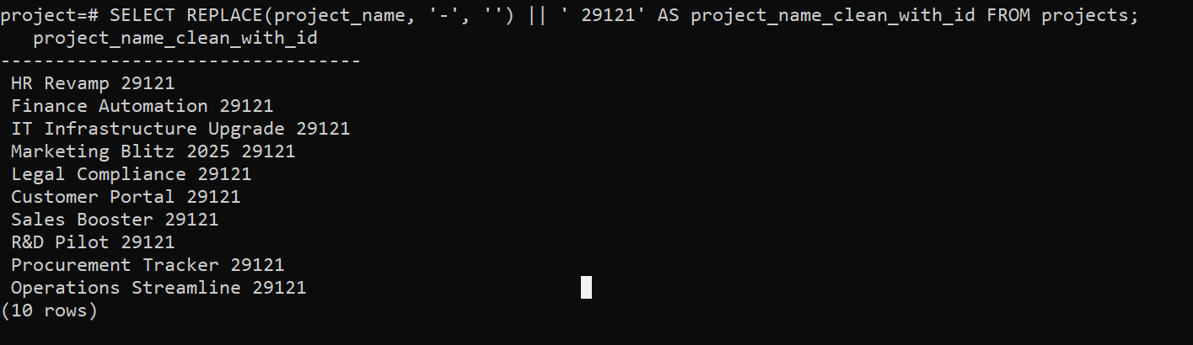

1. **Create a label like “Emp: John Doe (HR)”.**

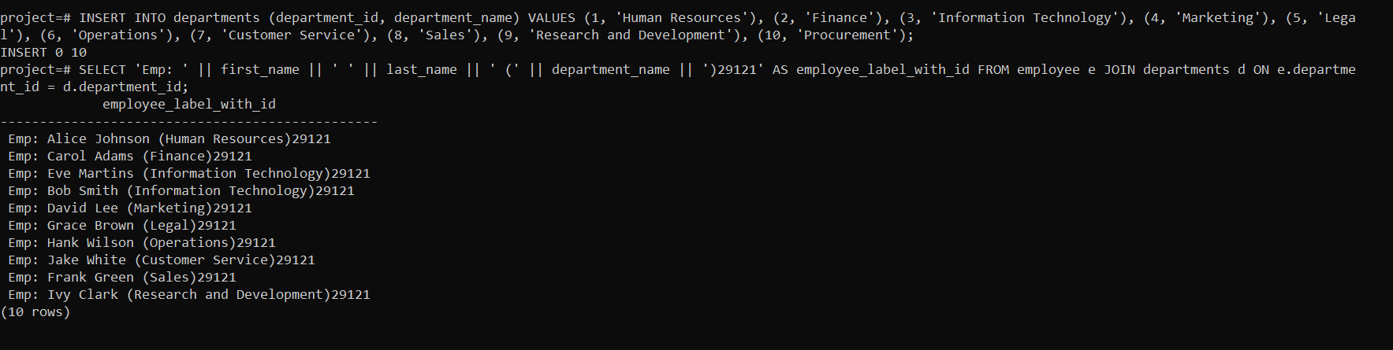

1. **Check email length for each employee.**

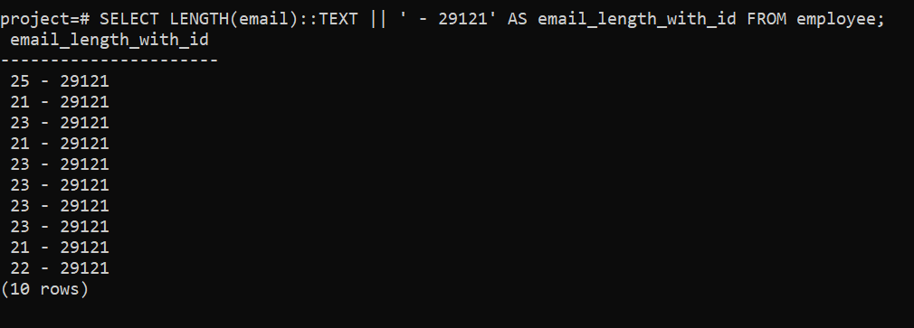

1. **Extract last name only from email (before @).**

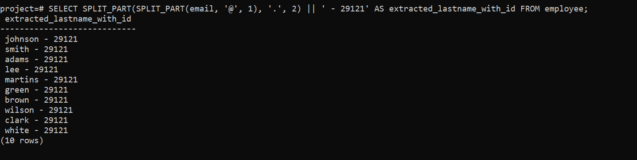

1. **Format: “LASTNAME, Firstname” using UPPER and CONCAT.**

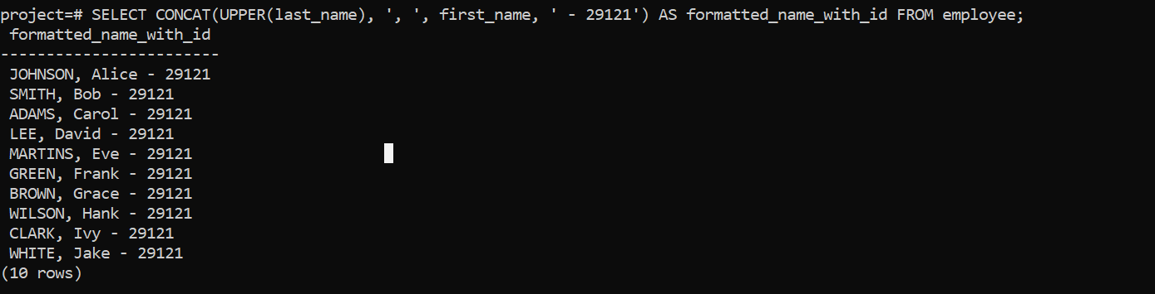

1. **Add “(Active)” next to employee names who have current projects. Numeric Function Exercises (10)**

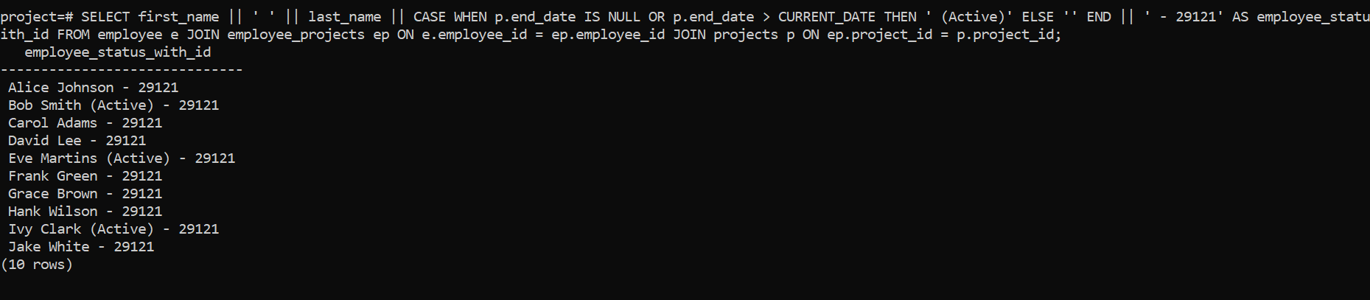

1. **Round salary to the nearest whole number.**

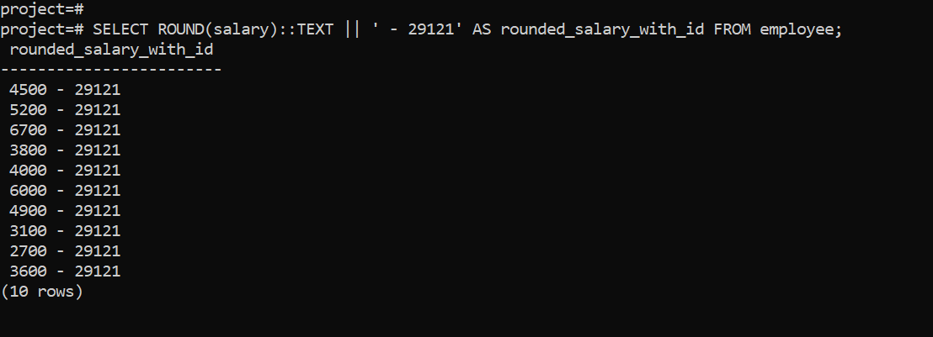

1. **Show only even salaries using MOD.**

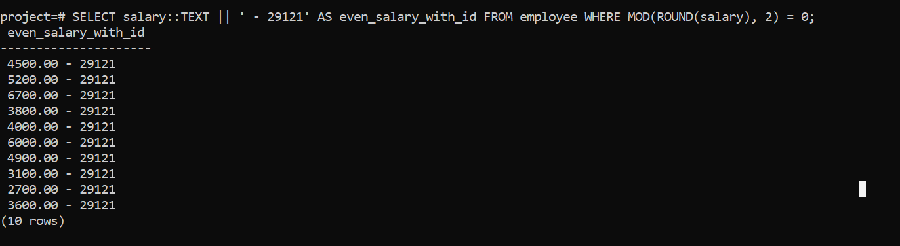

1. **Show difference between two project end/start dates using DATEDIFF.**

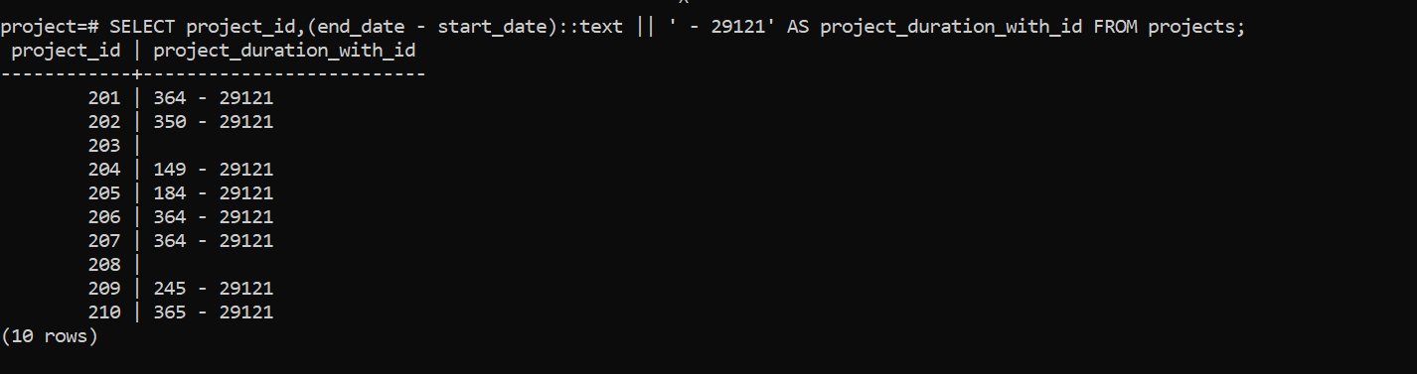

1. **Show absolute difference in salaries between two employees.**

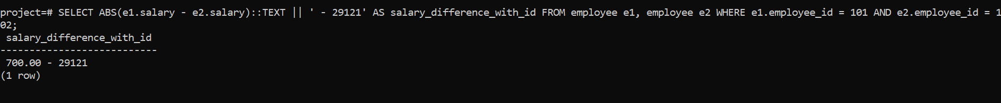

1. **Raise salary by 10% using POWER.**

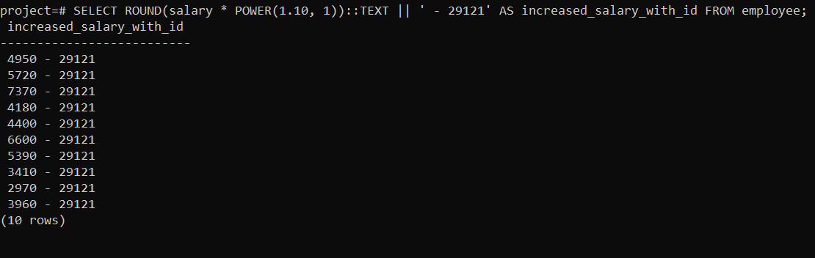

1. **Generate a random number for testing IDs.**

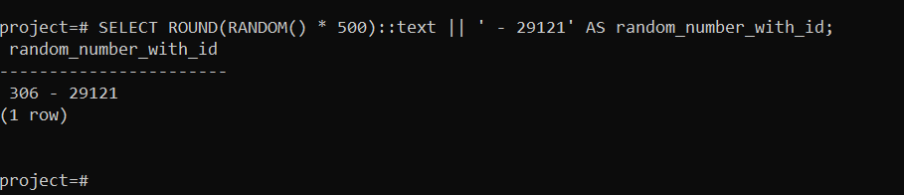

1. **Use CEIL and FLOOR on a floating salary.**

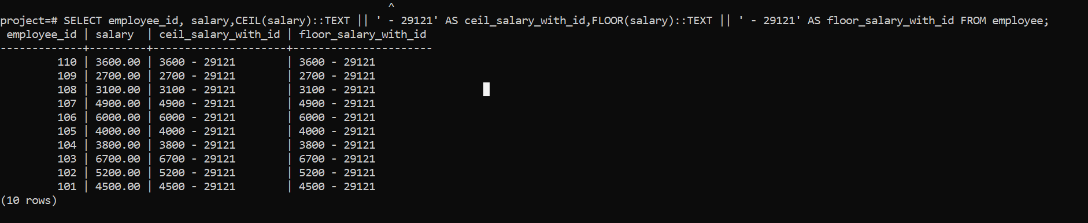

1. **Use LENGTH() on phone numbers (assume column exists).**

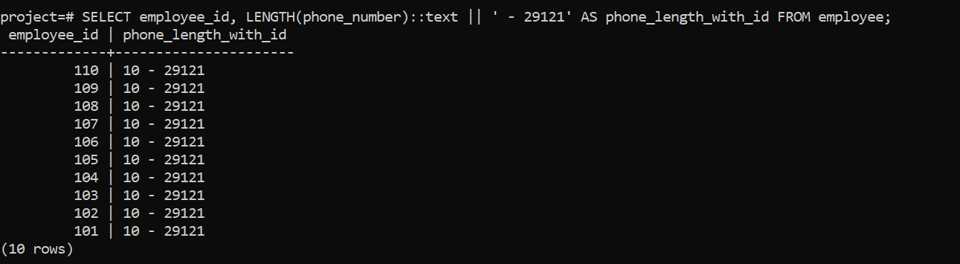

1. **Categorize salary: High/Medium/Low using CASE.**

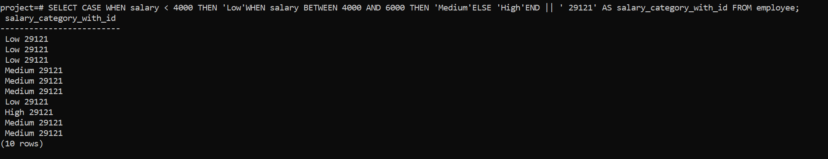

1. **Count digits in salary amount. Date/Time Function Exercises (10)**

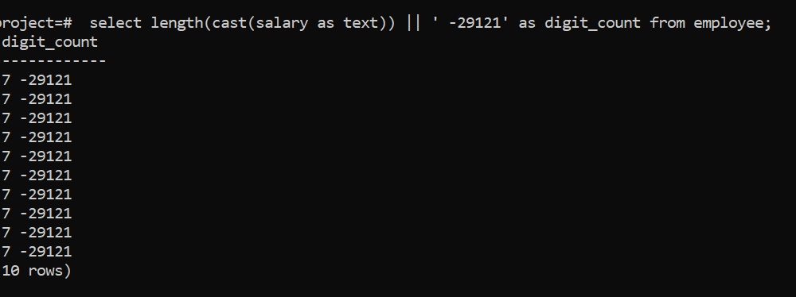

**26. Show today’s date using CURRENT_DATE.**

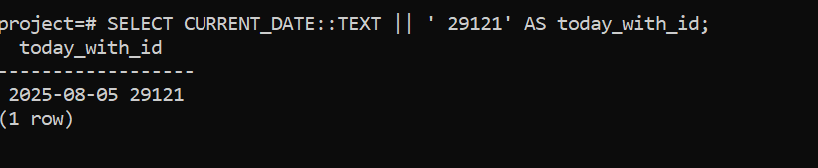 **27. Calculate how many days an employee has worked.**

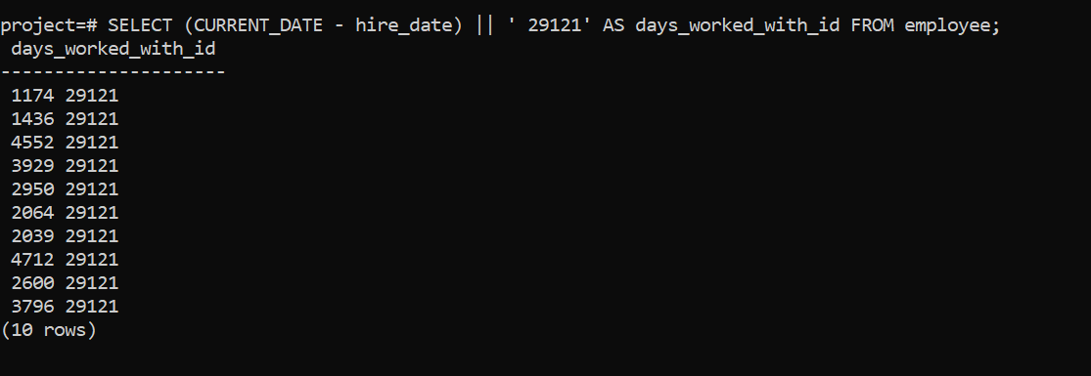**28. Show employees hired in the current year.**

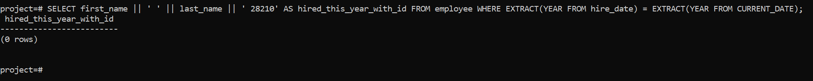**29. Display current date and time using NOW().**

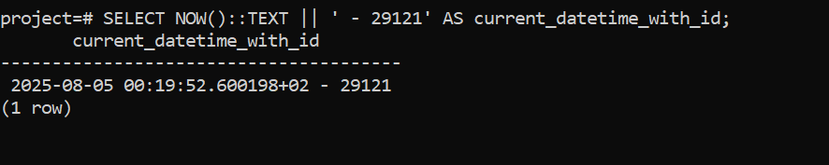

**30. Extract the year, month, and day from hire_date.**

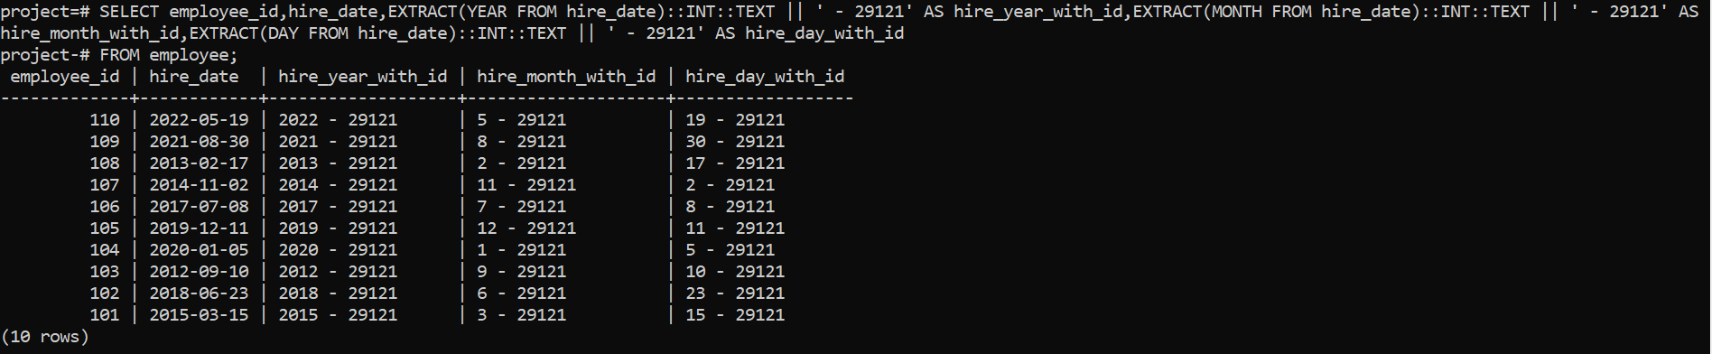

**31. Show employees hired before 2020.**

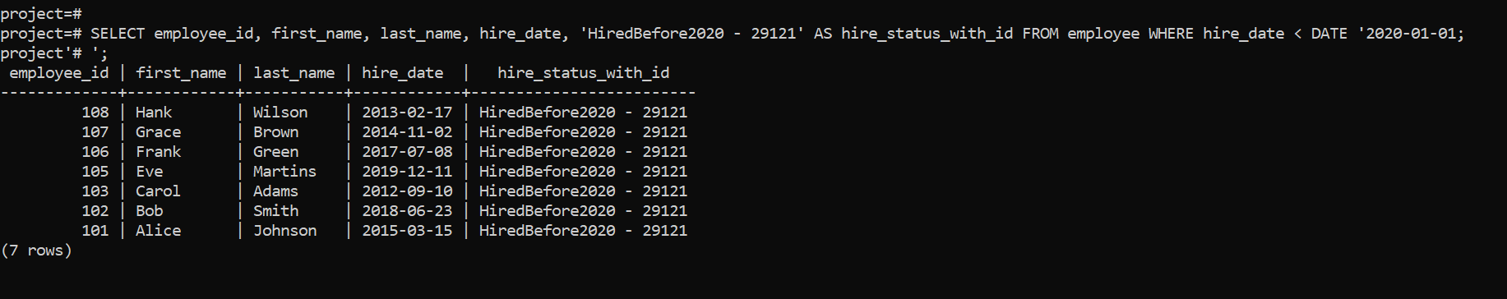

**32. List projects that ended in the last 30 days.**

**33. Calculate total days between project start and end dates.**

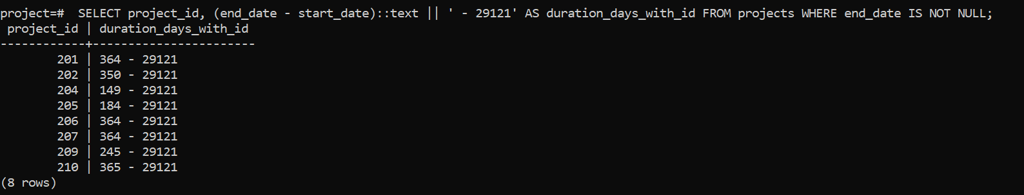**34. Format date: ‘2025-07-23’ to ‘July 23, 2025’ (use CONCAT).**

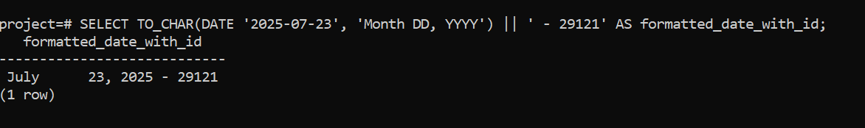

**35. Add a CASE: if project still active (end_date IS NULL), show ‘Ongoing’. Conditional Function Exercises (15)**

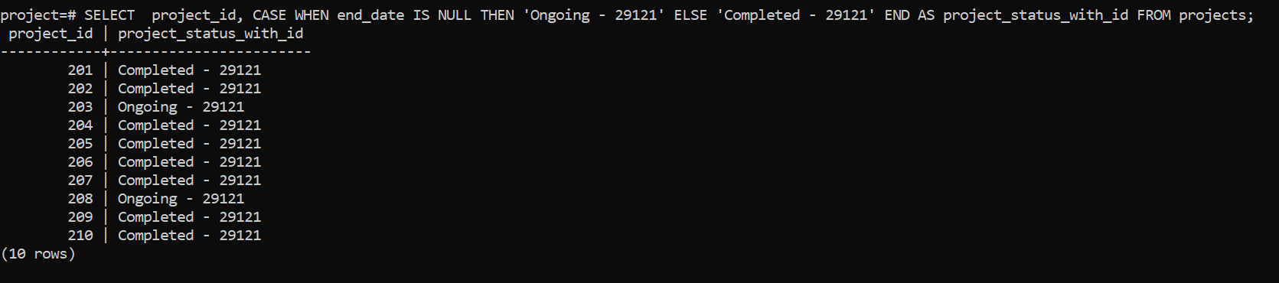**36. Use CASE to label salaries.**

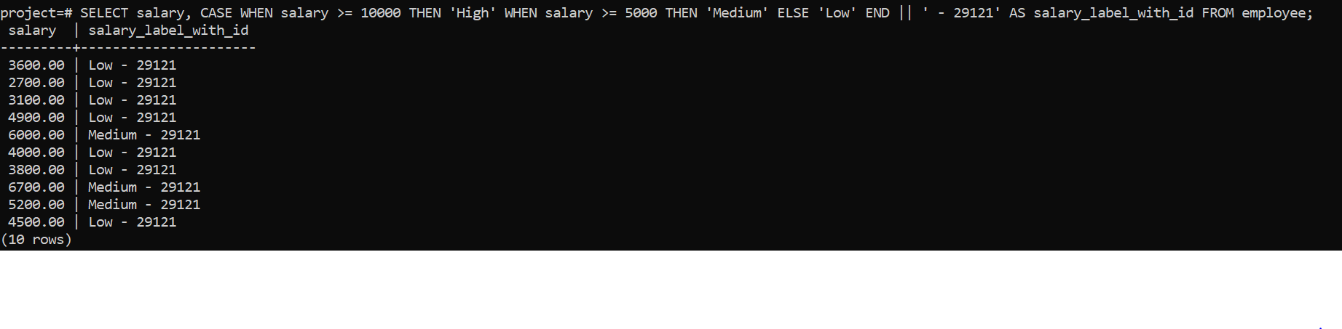

**37. Use COALESCE to show ‘No Email’ if email is NULL.**

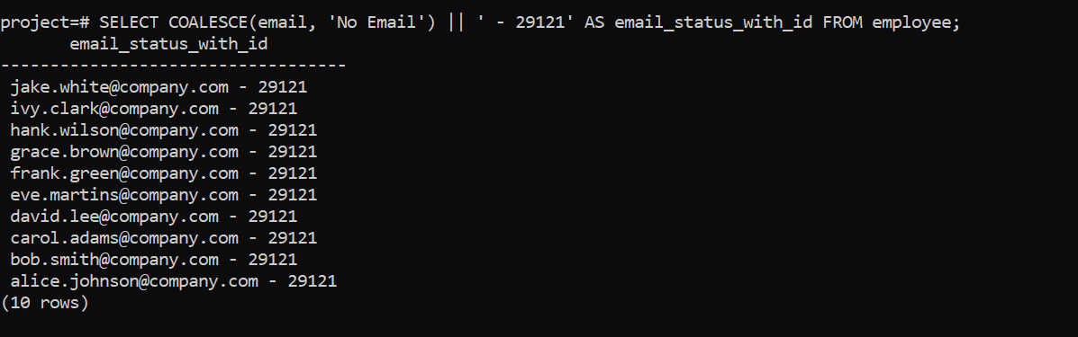

**38. CASE: If hire_date < 2015, mark as ‘Veteran’.**

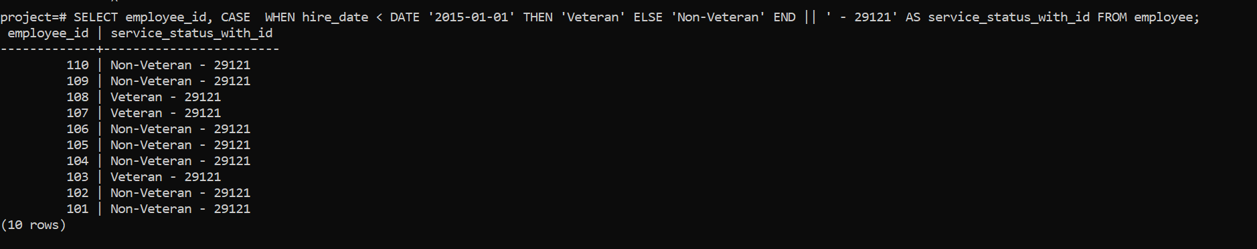

**39. If salary is NULL, default it to 3000 using COALESCE.**

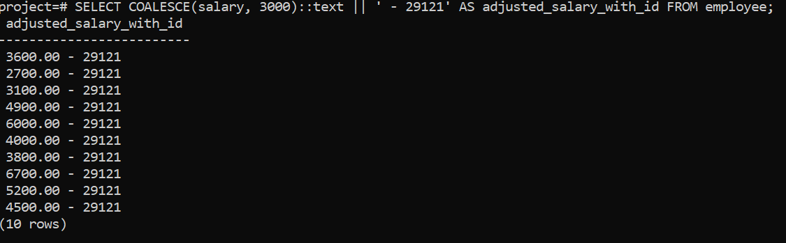**40. CASE: Categorize departments (IT, HR, Other).**

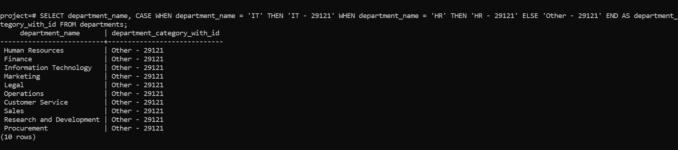 **41. CASE: If employee has no project, mark as ‘Unassigned’.**

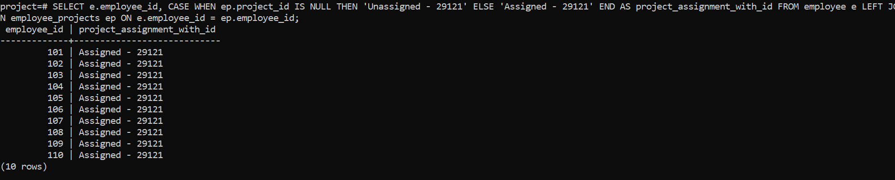 **42. CASE: Show tax band based on salary.**

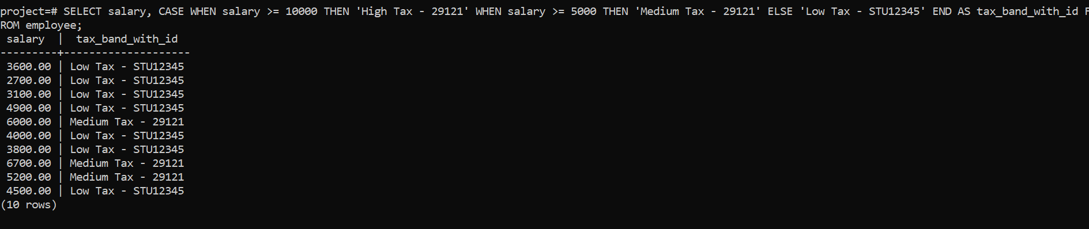

**43. Use nested CASE to label project duration.**

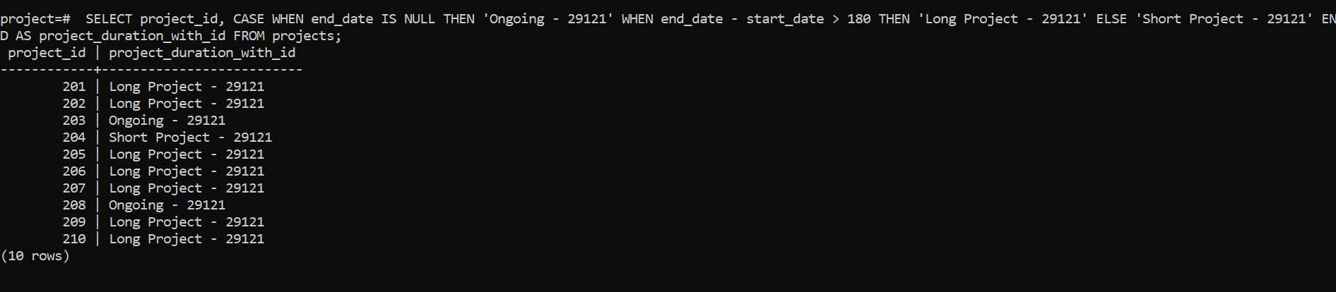

**44. Use CASE with MOD to show even/odd salary IDs.**

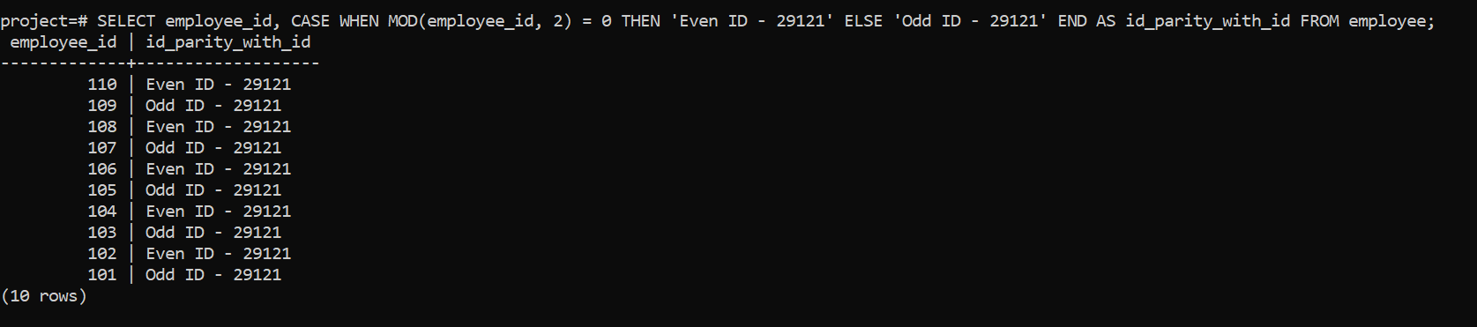**45. Combine COALESCE + CONCAT for fallback names.**

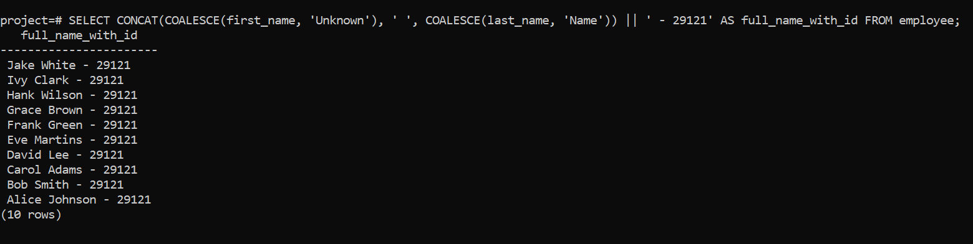

**46. CASE with LENGTH(): if name length > 10, label “Long Name”.**

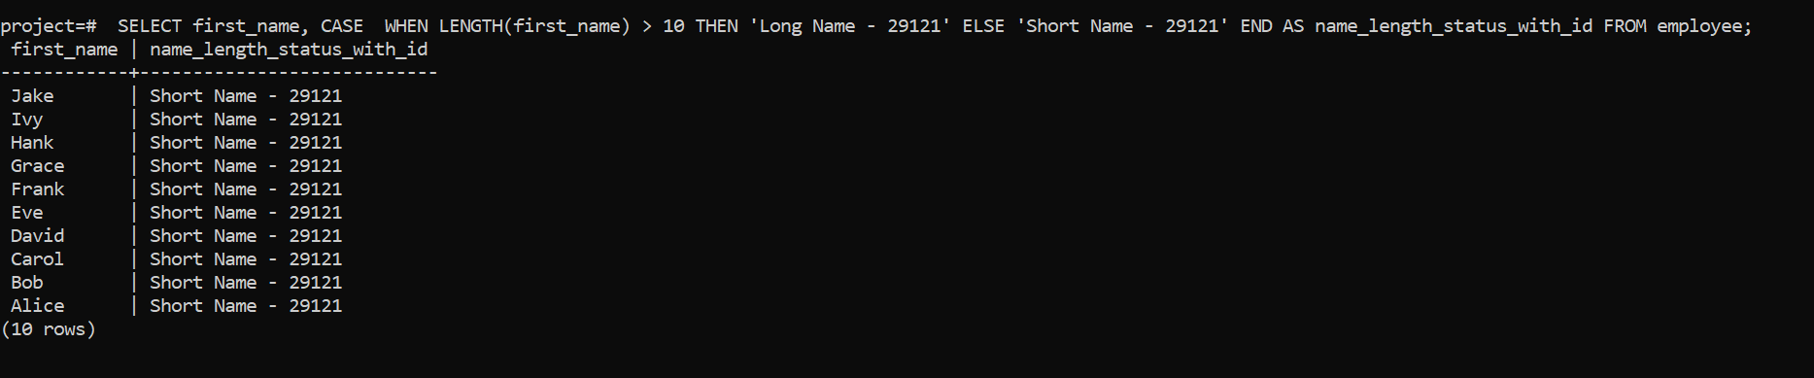**47. CASE + UPPER(): if email has ‘TEST’, mark as dummy account.**

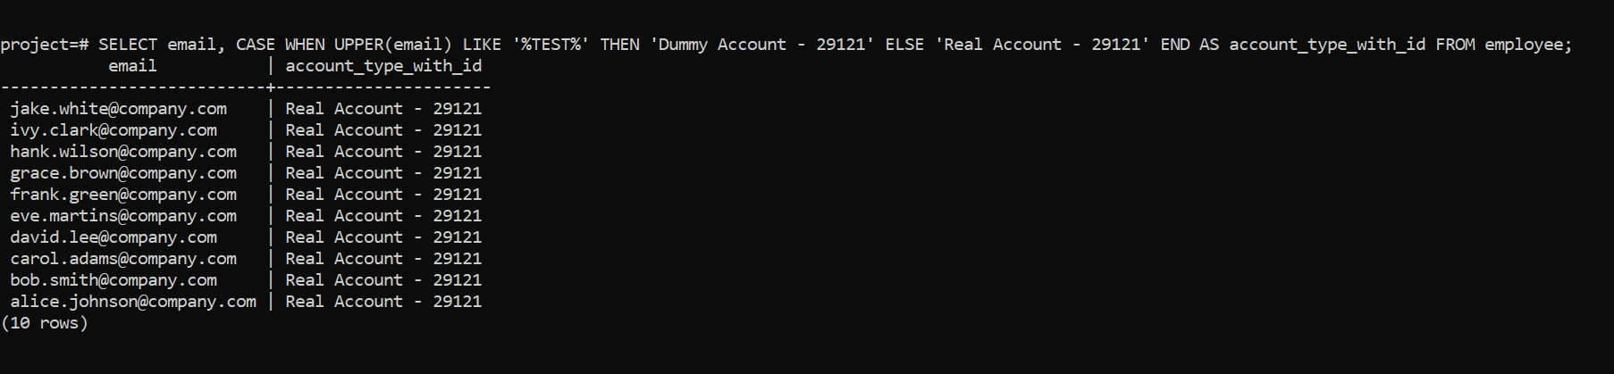**48. CASE: Show seniority based on hire year (e.g., Junior/Senior).**

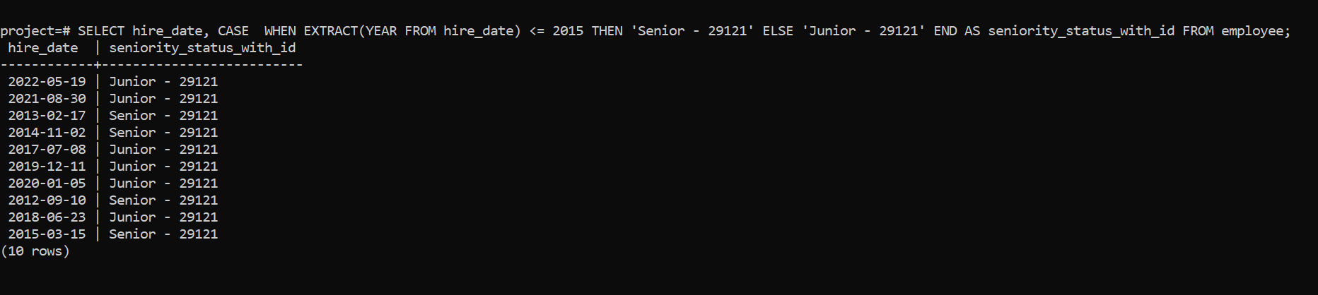**49. Use CASE to determine salary increment range.**

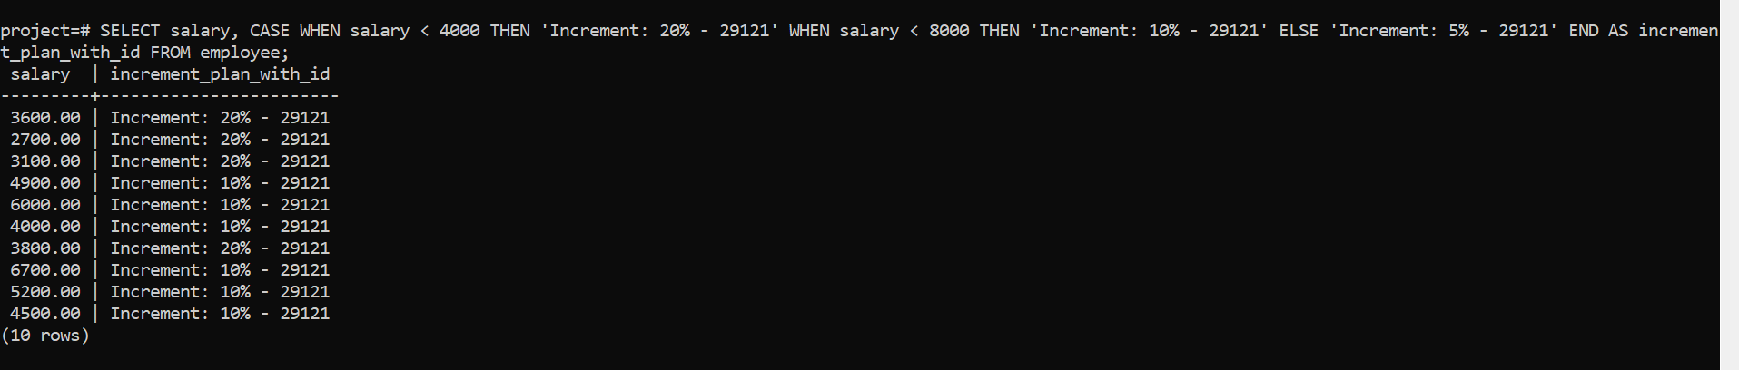

**50. Use CASE with CURDATE() to determine anniversary month.**

